# Introduction of usage

## Installation

Requirement: Framework 4.6.2

For downloading the framework 4.6.2, you can find from [here](https://www.microsoft.com/en-us/download/details.aspx?id=53344).

## Launch the program

1. Open command prompt;
2. Locate the exe file of ConstructionCalculator.Utility.exe
3. Type the command line e.g. C:\Users\ssu2\Documents\GitHub\ConstructionCalculator\ConstructionCalculator.Utility\bin\Debug\ConstructionCalculator.Utility.exe clean

## Cleanup data

Parameter: ***Clean***

Cleanup data is for cleaning all exists data from database

Command Sample:

C:\Users\ssu2\Documents\GitHub\ConstructionCalculator\ConstructionCalculator.Utility\bin\Debug\ConstructionCalculator.Utility.exe clean

The result such as the following screenshot after command executed;

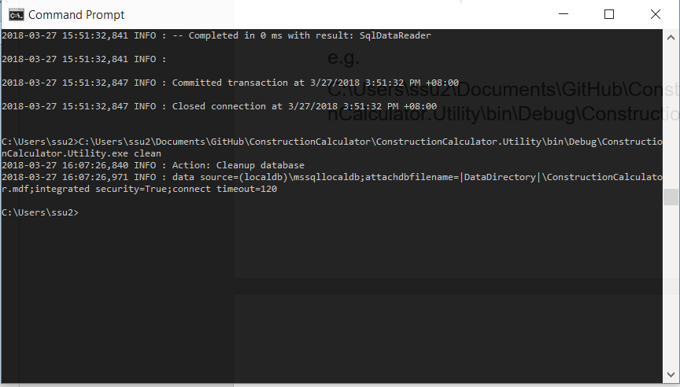

## Import parameter tables

Parameter: ***Import***

Import is importing data from the folder of app folder/importdata, you can update the parameter excel files in this folder then execute clean and import command;

Command Sample:

C:\Users\ssu2\Documents\GitHub\ConstructionCalculator\ConstructionCalculator.Utility\bin\Debug\ConstructionCalculator.Utility.exe import

After import command is executed, the result like the following screenshot

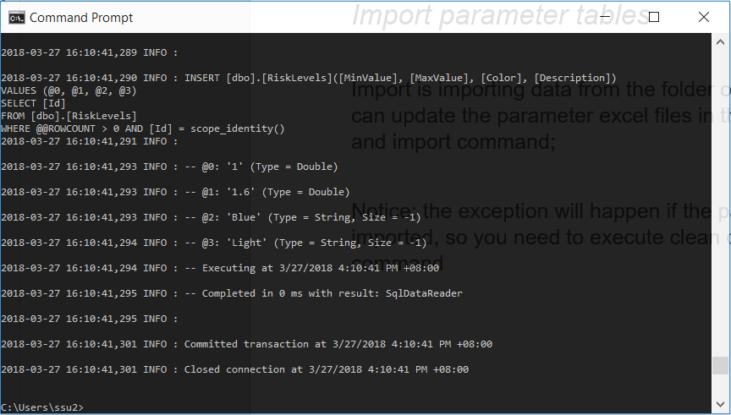

Notice: the exception will happen if the parameter data has been imported, so you need to execute ***clean*** command before ***import*** command

## Calculate folder

Parameter:

* Calc
* Folder Path

Sample Command:

C:\Users\ssu2\Documents\GitHub\ConstructionCalculator\ConstructionCalculator.Utility\bin\Debug\ConstructionCalculator.Utility.exe ***calc*** **C:\Users\ssu2\Documents\Tests**

After command executed, you can see the files generated double times in the folder which you specified in command line, the file which with processed are calculated files;

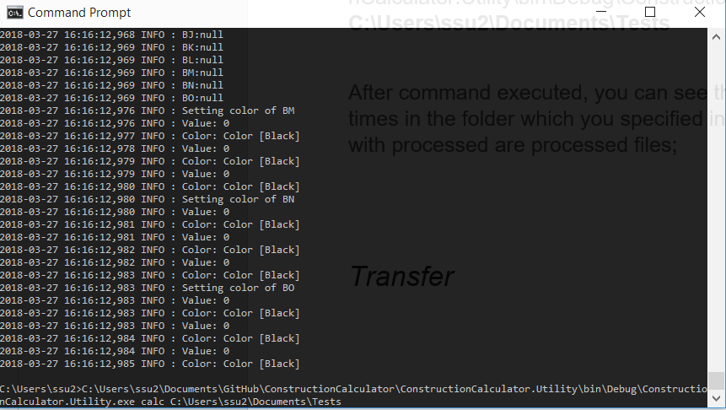

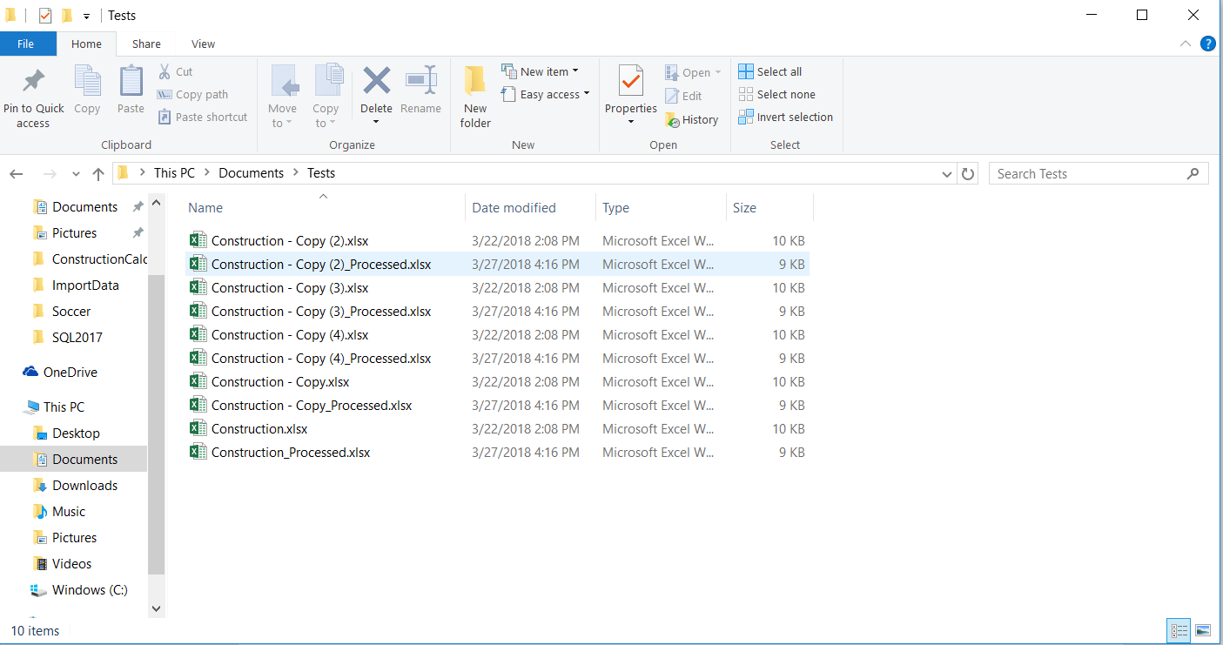

## Transfer

Parameter: ***Transfer***

Transfer is for transferring the xls(excel 2007 or lower version) to xlsx(excel 2013 or higher version)

Command Sample:

C:\Users\ssu2\Documents\GitHub\ConstructionCalculator\ConstructionCalculator.Utility\bin\Debug\ConstructionCalculator.Utility.exe ***transfer***

After transfer action, the xls files will be saved as xlsx files (in highlighter);

